Ajeet Kotturu, Matthew Wang

Period 4

BattleZone

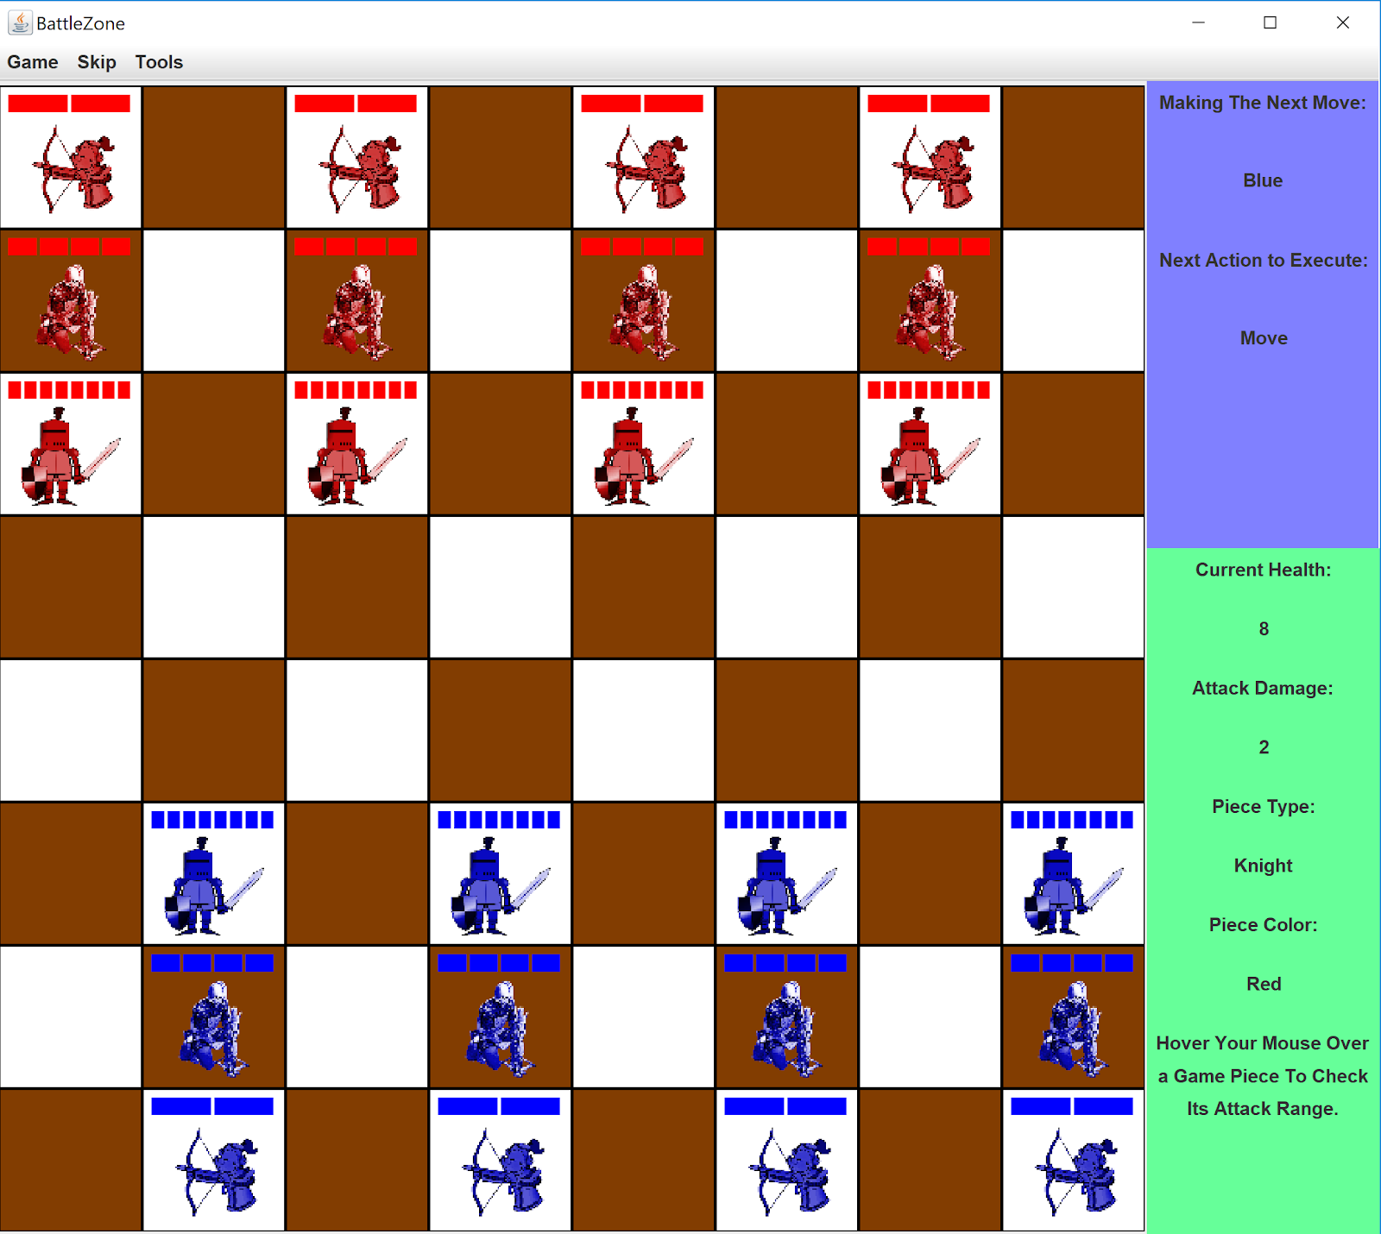

**Game Concept**

The game is a two player game played on a 8 by 8 game board. Each player has three kinds of pieces. The goal for a player is to eliminate all the opponents pieces. When a player’s piece attacks the opponent’s piece, the opponent’s piece loses health. When a piece’s health becomes zero, the piece is removed from the game. The player that eliminates their opponents pieces first wins.

**Pieces**

There are three kinds of pieces. Each piece has an attack, health, moveset, and range.

**The Knight**

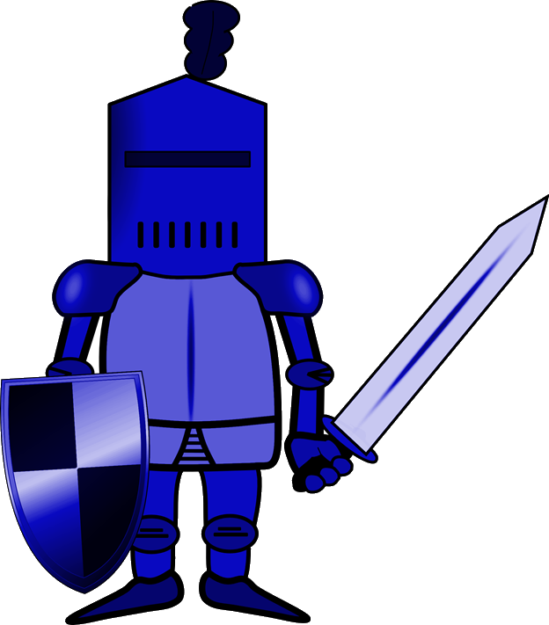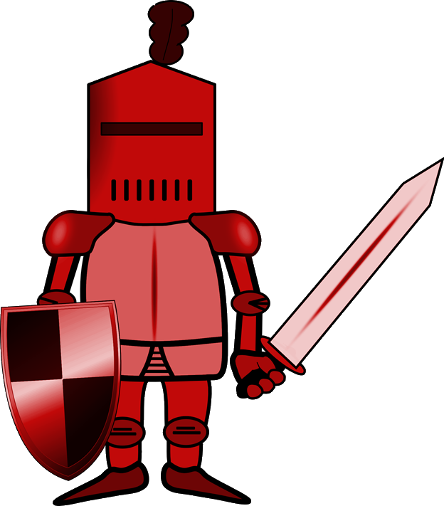

PieceType: PieceOne

Health: 8

Attack: 2

Range: Small

**The Crossbow**

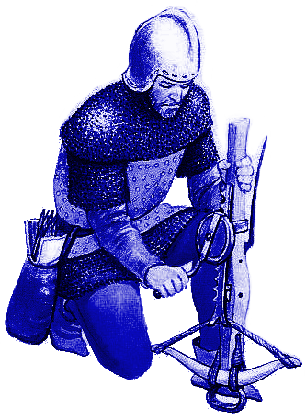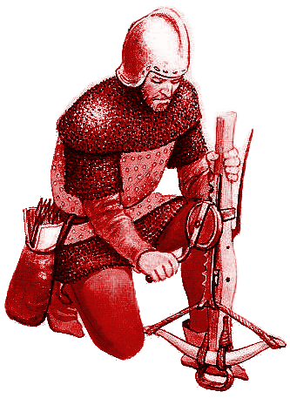

PieceType: PieceTwo

Health: 4

Attack: 3

Range: Medium

**The Longbow**

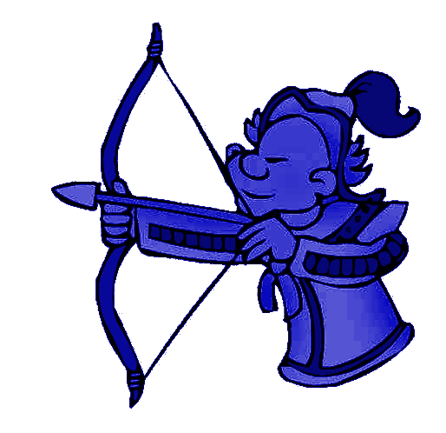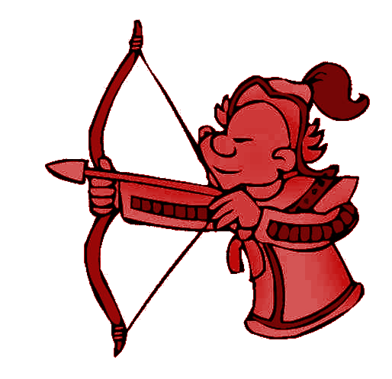

PieceType: PieceThree

Health: 2

Attack: 1

Range: Large

**Movesets**

The squares the piece can move to are shown in the image below

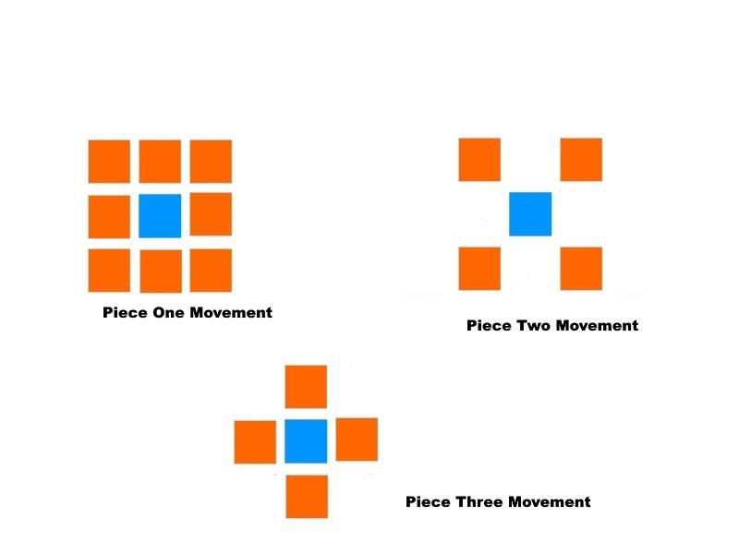

**Attacks**

The squares where the piece can attack are shown in the image below

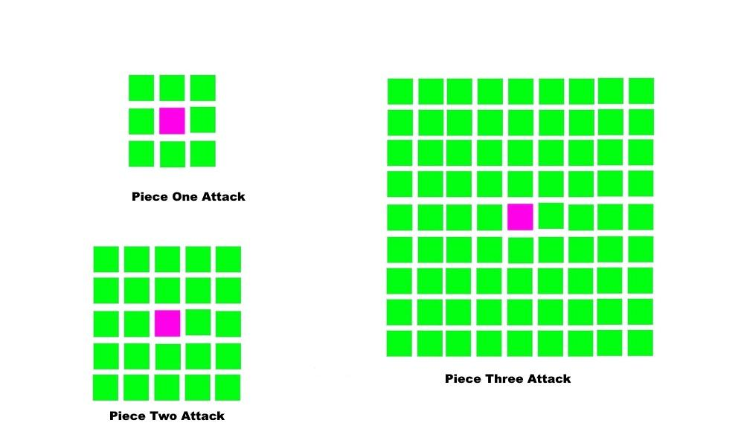

**Move Order**

Player One Moves first. Then Player Two Moves. After that, Player Two Attack. Then, Player One Attack. The Cycle repeats like this for the rest of the game. If player cannot attack opponent, player can skip turn.